Luis Medina
D600 Task 1
012020203

B1: Proposal of Question
For this assignment, the question I am going to answer throughout the analysis is, how does the square footage, number of bedrooms, and number of bathrooms affect the price of the houses from the data set provided.
B2: Defined Goal
The goal of the question is to build a multiple linear regression model that will predict house prices using square footage, number of bedrooms, and number of bathrooms as predictors. This will give us an idea of what factors have the most impact on the housing market and will give me helpful insights on how they value property.
C1: Variable Identification
Here I am going to look at what the dependent and independent variables will be. The dependent variable (y)
- Price: It will represent the market value of the house, that is what we want to predict in the project.
Independent variable (X):
- Square Footage: Looking at the measurement of the house, which usually influences price.
- Number of Bedrooms: Total number of bedrooms in the house, which can affect demand and price of the house.
- Number of Bathrooms: Indicates the number of total bathrooms in the house, also has an impact on the price of the house.

C2: Descriptive Statistics
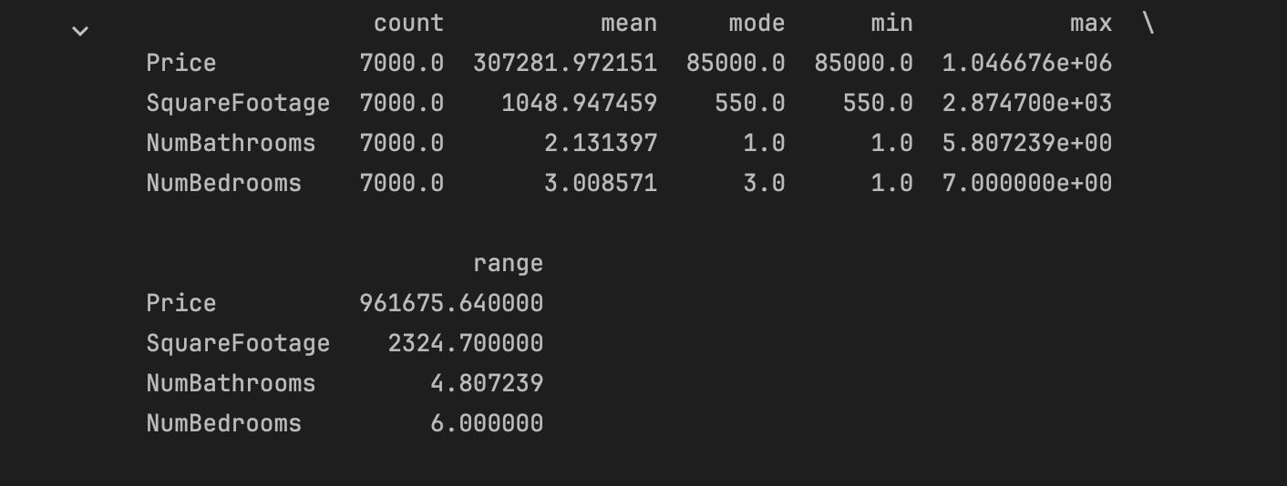
Here are some descriptive statistics about the variables I am using in the assignment.
- Price: looking at price we can see it ranges from about $85,000 to $1 million, with an average of $307,281.
- Square Footage: looking at the square footage it ranges from 550 to 2874 and an average of 1048 square footage.
- Number of Bathrooms: Looking at the number of bathrooms it ranges from 1 to about 6 bathrooms with an average of 2 bathrooms.
- Number of Bedrooms: looking at the number of bedrooms it ranges from 1 to 7, with an average of 3 bedrooms.
C3: Visualizations
Here are some visualizations for univariate statistics.
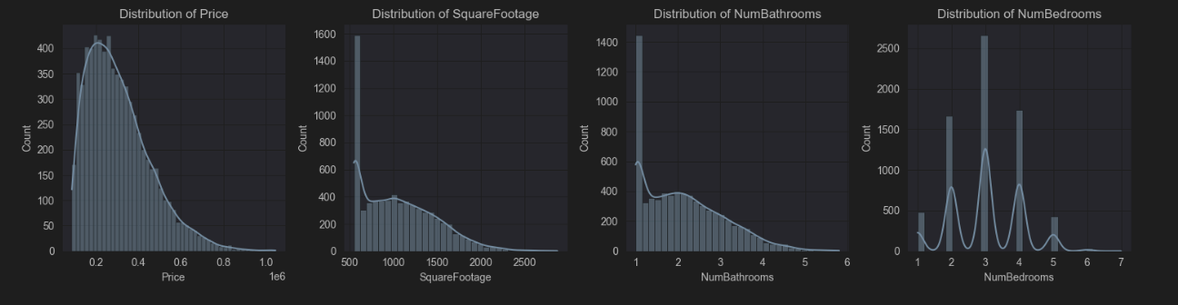
Here I will explain a little with what is happening with the graphs.
- Price
  - The histogram is right skewed, that means most of the house fall between 100k and 500k
- Square Footage
  - Here most of the data points lie between 700 – 1500 sqft with not that many house on the far right. Like the previous it is also right skewed.
- Number of Bathrooms
  - Now looking at the number of bathrooms, it shows that most house have between 1.5 – 3 bathrooms, and once again with a slight right skewed.
- Number of Bathrooms
  - Lastly, looking at the final graph, it shows that most house have around 2-4 bedrooms, with 3 bedrooms being the most common or most frequent one happening.
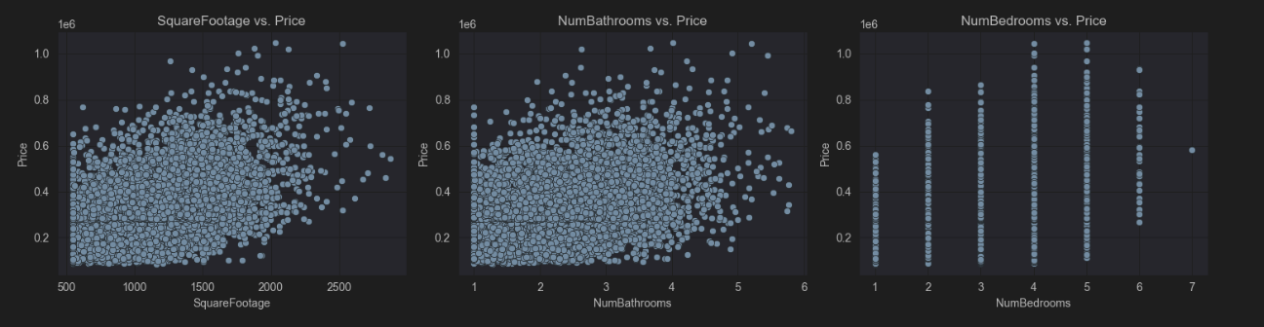
Let’s go over the graphs created in this part of the section.
- Price vs Square Footage
  - Here we can see there is a positive relationship, meaning that as square footage increase so would the price of the house.
- Price vs Number of Bathrooms
  - Here the relation is somewhat the same as above just not as strong meaning that with the increase of Bathrooms the price will slight be impacted. Although you can see that some 2 Bathrooms cost a lot more than more bathrooms, this means that it is a factor, but it’s not the dominant driver for the price.
- Price vs Number of Bedrooms
  - The relation here is a lot weaker compared to the first graph. The price does increase as bedrooms goes up there is also a lot of overlap, meaning that bedrooms will add value but does not explain the price difference like square footage.

D1: Splitting the Data
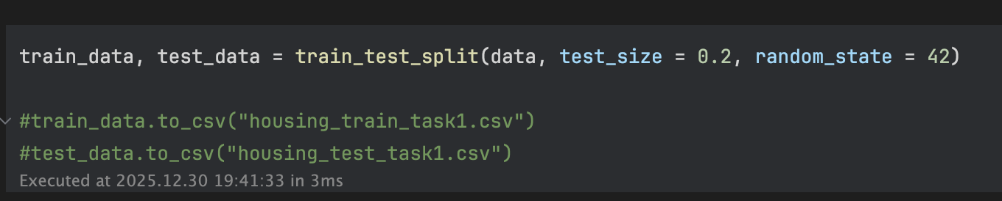
Here is the code used to split the data into testing and training.
D2: Model Optimization
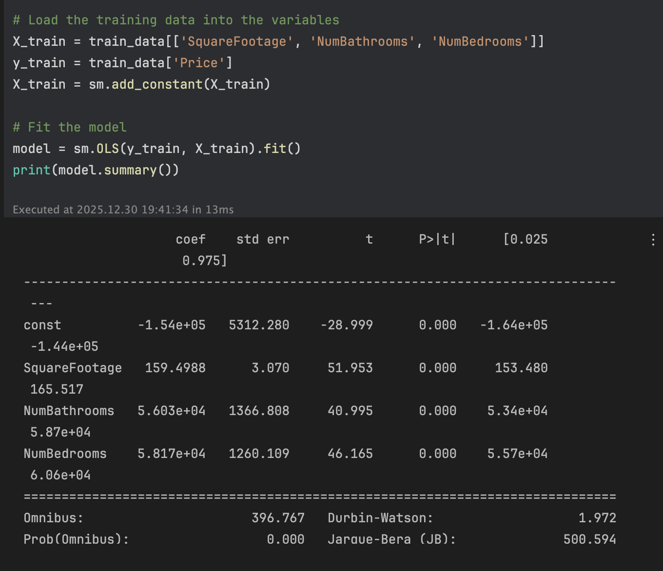
Here is the model summary
- R-squared: 0.596
- Adjusted R-squared: 0.595
- F-statistic: 2747
- Prob (F-statistic): 0.00
- Coefficient
  - Intercept: -154,000
  - Square Footage: 159.5
  - Number of Bathrooms: 56,030
  - Number of Bedrooms: 58,170
D3: Mean Squared Error
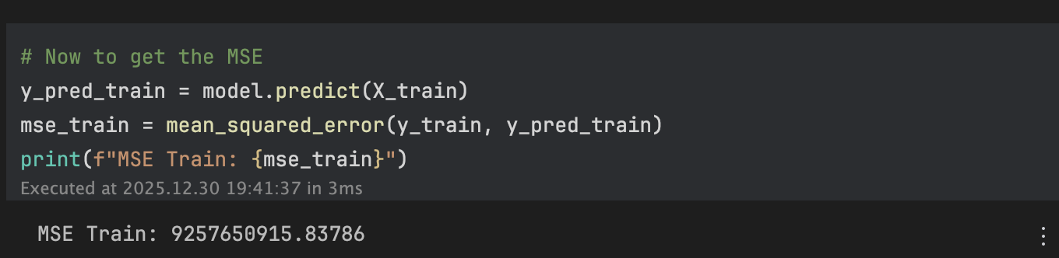
The mean squared error (MSE), was calculated using the training data and the result was: 9,257,650,915.84, which shows the average squared prediction error. This currently aligns with expectation given the variation in housing prices and the dependent variable.
D4: Model Accuracy 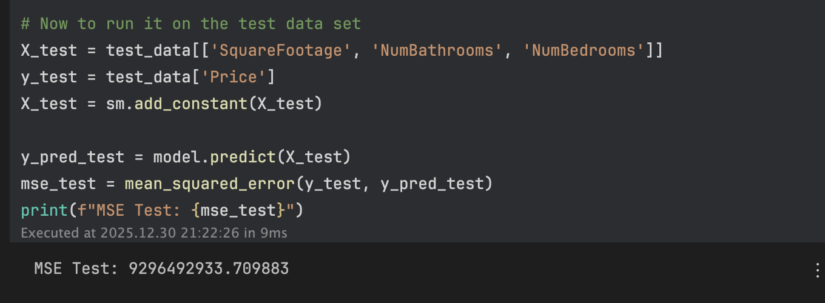
Here for this part, I used the test data to evaluate how the regression model that I created above will do with data it has never been used. The testing MSE was: 9,296,492,933.71, which represents the average squared difference between the actual and the predicted housing prices from the testing data set that was used above. Comparing the two results from the training data and the testing data the values are similar, meaning that the model is not overfitting and that it maintains consistent predictive accuracy.
E1: Packages or Libraries List
The packages that I used for this assignment are:
- Pandas: For loading the data, cleaning, and doing any changes to the data.
- Numpy: This package was for handling any calculations like handling the array during the regression part of the assignment.
- Matplotlib/ Seaborn: These packages were used to create visualizations
- Statsmodels: This package was used to perform multiple linear regression models, to extract the parameters needed, and to view a summary of the results.
- Scikit-learn: This package was used to split the data into training and testing subsets and to calculate the MSE.
E2: Method Justification
The method I used for this assignment was backward stepwise elimination, the reason for this is that it allows us to start with our hypothesized factors and statistically remove those that do not contribute to the model. For this assignment all three of the proposed variables were statistically significant, so all were retained in the final optimized model.
E3: Verification of Assumptions
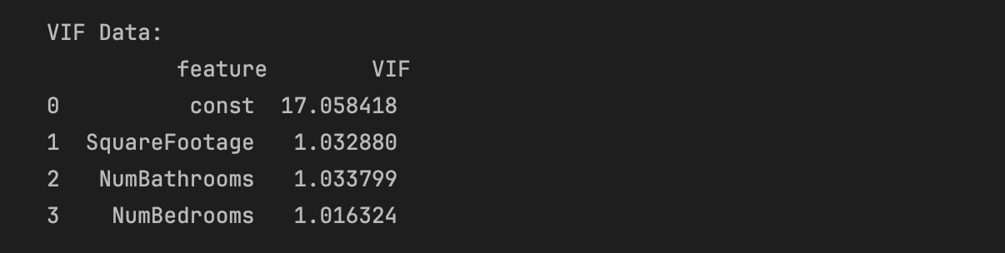
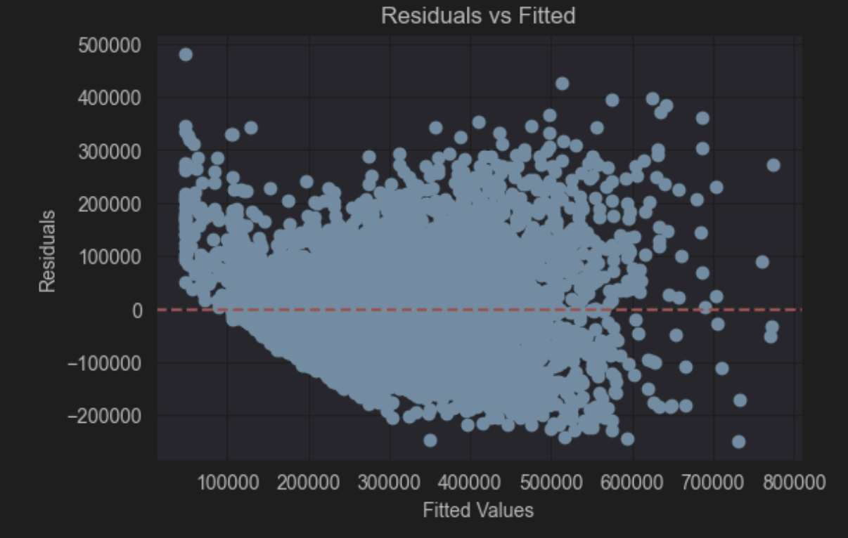
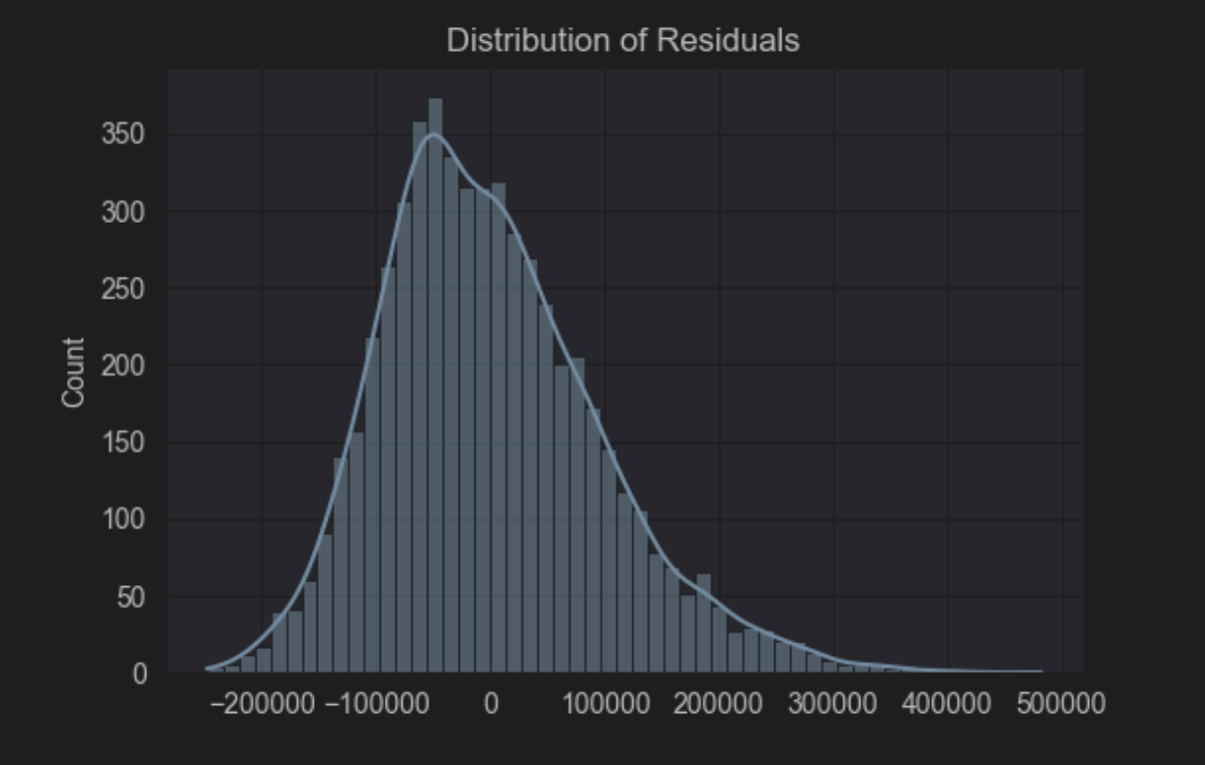
Here I will show how the assumptions for multiple linear regression were verified starting with:
- Linearity: First, the bivariate scatter showed above that they had linear trends between predictors and Price.
- Multicollinearity: This was verified using the VIF; all the values were approx. 1.01 – 1.04, which is below the threshold of 5 or 10, so then it indicates that there is no multicollinearity.
- Homoscedasticity/ Normality: The residual was analyzed, while there was some variance the large sample size makes the OSL estimate robust.
E4: Equation
Here is the regression equation that was developed from the data provided. Price = -154,000 + 159.50 (Square Footage) + 56,030 (Number of Bathrooms) + 58,170 (Number of Bedrooms). Here the intercept (-154,000), this represents the base house price if square footage, bedrooms, and bathrooms were all zero. Next, the square footage (159.50), this coefficient indicates that for everyone additional square foot of living space, the predicted price of the home increases by approximately $159.50, this is assuming that the number of bedrooms and bathrooms remains constant. Then, for Number of Bathrooms (56,030), which will indicate that the addition of one bathroom the property price will increase by $56,030. Lastly, Number of Bedrooms (58,170), this will indicate that with the addition of one bedroom the predicted price of the property will increase by approximately $56,030.
E5: Model Metrics
Now for this part I am going to explain what the R^2, Adjusted R^2 and the MSE mean in terms of the question asked in the first part.
- R^2 = 0.596 and Adjusted R^2 = 0.595.
  - This means that about 59.6% of the variation in house prices can be explained by square footage, number of bathrooms, and number of bedrooms.
- Training MSE = about 9.25 billion and test MSE = 9.3 billion
  - By looking at the results, we can see that in both the training and test dataset, the MSE is very close to each other. This indicates that the model generalizes well and does not overfit the training data.

E6: Results and Implications
From the analysis above, the linear regression model produced a R-squared value of 0.596, meaning that approximately 59.6% of the variation in house prices can be explained by the structural features of square footage, number of bathrooms, and number of bedrooms. Although this is a strong relationship, there are still other factors not included in the model such as Distance to City Center, School Rating and Renovation Quality that most likely play a role in changing the value. Then the Root Mean Error (RMSE) was approximately $96,217. Given that average home price is around $300,000, a margin of error of nearly $100K is quite large, indicating the model is not precise enough for exact pricing. Another, thing I can see from the model is that adding a bedroom or bathroom adds significant value about $58K and $56K, meaning that renovations projects which add a room for less than these amounts would likely result in a positive return on investment.
E7: Course of Action
Now for some course of action, based on the analysis results, by looking at the positive coefficients but high RMSE here is what I recommend. First, use this model as a screening tool and not a pricing tool, meaning don’t use the model to set the final price. Instead, use the equation to calculate baseline estimates for incoming inventory. Another action is that the organizations should prioritize acquiring properties with large square footage, but low bedroom counts, as the data shows that the market pays a premium for an extra bedroom. Lastly, the team in charge of the model should include the location-based variables to help reduce the RMSE that we got above. Reducing the RMSE to a more acceptable range will make the model more trustworthy and then be trusted for automated decision making.
F: Panopto Recording
The link for the video will be included when the assignment is submitted.
G: Sources
No sources were used in the assignment, just the material provided in the class material.

